The IS mains filter has been designed to protect security, fire, CCTV, door access systems and industrial control systems from induced radio frequency interference and high voltage transient ‘spikes’ via the 230 V AC mains supply. Interference can be caused by a nearby lightening strike, inductive loads being switched, electric motors being badly suppressed, etc.
(ISUBMF AND ISMF)
MAINS FILTERS

If the transient spike is of a high enough voltage it will cause the varistors to breakdown and the transient will be safely earthed. This acts like a fuse blowing and the filter will have to be replaced.

Warning: Any system containing a mains filter should not be tested by a high voltage
resistance tester without the mains filter being removed first

- Fit the mains filter as close as practicable to the equipment being
protected.
- Connect to the mains supply via a
2.5 mm twin and earth cable.
- The mains filter must be properly earthed.
- Ensure the fuse fitted is correct for the load.
- The maximum load for the mains filter is 3.5 Amps

This product is also available assembled into a Fused Spur which is rated at 3 Amps. Part number is ISMF.

Packing Weight | ISUBMF: 95g  ISMF: 340g

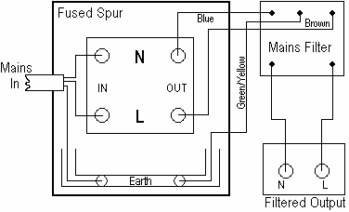

Drawing shows connections to a Fused Spur

