This versatile 1 second to 64 minute ISARMv3 now has a new mode 7 in addition to the previous version’s 6. Timing period potentiometer is replaced by a DIL switch enabling quicker and more accurate time settings. Time range is extended to 64 minutes.
(IS ARM)
ADVANCED RELAY MODULE

Individual +ve & -ve terminals for trigger and reset eliminate the need for jumper links to select polarity of both.

Auto voltage selection – just connect either 12 or 24volts DC to the power terminals and the ISARMv3 will do the rest.

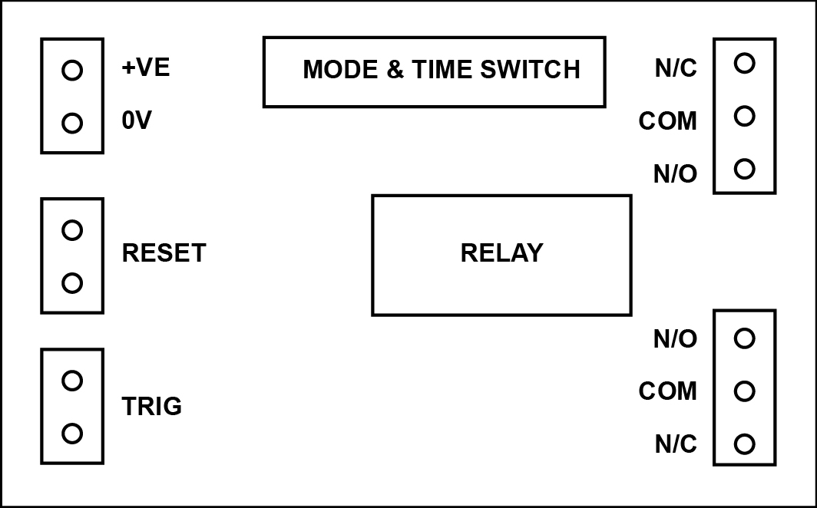

Operating Modes:

Mode 1 Relay latches on after a trigger
– requires a reset

Mode 2 Relay on for the timed period
after a momentary trigger

Mode 3 Relay on whilst trigger is
present, stays on for timed period after trigger removed, timer resets if trigger re-applied during time period, – thus extending the time period

Mode 4 Relay on after trigger present for more than timed period, off when trigger removed

Mode 5 Relay on whilst trigger is applied for a maximum of the timed period

Mode 6 Timed period starts after trigger is removed, relay on if trigger not re-applied before time out

Mode 7 Momentary trigger, relay on for set time period, off at end of time period. Or if trigger is still present after time period relay on until trigger removed

Operating Voltage | 10 - 24 Volts DC
Quiescent Current | 15mA at 12 V  17mA at 24 V
Relay Active | 39mA at 12 V  41mA at 24 V
Operating Conditions | -10°C to +60°C
Trigger and Reset | High: >5 V DC  Low: <0.8 V DC
Relay Contacts | Min 10mA, Max 8A at 240V AC & 30V DC
Supply Input | Reverse polarity protected
Dimensions | 56mm (W)  90mm (L)  18mm (H)
Packing Weight | 50g

