The 12 volt double pole relay is a simple to fit module wherever a dry contact, voltage free
(IS 12)
12V POLARISED RELAY

switching is required or where there is a need for higher than usual currents and voltages to
be switched. The polarised function enables it to be used in Intruder Alarm and similar systems where the polarity of the output to the bells, sounders etc. is reversed when in alarm.
Note: Polarity must be correct for the relay to activate.

The 12 volt relay is mounted on a printed circuit board that has screwed terminals, complete with LED indication.

Common applications include switching extra sounders and lights in security systems,
actuating barriers and doors in access control systems, switching cameras and lighting in
CCTV systems and many applications in industrial control systems.

Supply Voltage | 12 Volts DC
Coil Resistance | 360 Ohms
Nominal Current | 58 mA
Double Pole Relay rated at | 8 Amps at 240 V AC  8 Amps at 30 V DC
Minimum switching current | 10 mA (see note)
Dimensions | 56mm (W)  60mm (L)  30mm (H)

For a neat, easy and safe fixing we recommend the use of IS Sticky Feet Size B, a self adhesive mounting pillar.

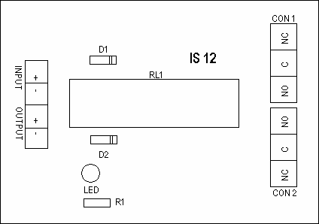

Note: Minimum current (wetting current) is what is required to keep contact clean

