The IS 60T AC timer is a simple low cost and versatile timer that is suitable for security, fire,
(IS 60T AC)
0-60 SEC/MIN TIMED RELAY

door access, CCTV systems and many other applications where a reliable timer is required.
It has been designed for 12 or 24 volt AC operation and has a double pole relay rated at 8 Amps 240 Volts AC complete with LED indication.

Time intervals:
Range 1 0-60 seconds, adjusted by the
potentiometer
Range 2 1-60 minutes, selected by plug
in link JP2 and adjusted by the
potentiometer.

Two modes of operation are provided and are selected by plug in link JP1.

Mode 1
Link pins 1 and 2 on JP1. The relay activates for the timed period. In Mode 1there are 3 options.
A. With JP4 link out, apply a momentary trigger. The relay will activate for the timed period and then de-energise.
B. With JP4 link in, apply a momentary trigger. The relay will activate for the timed period and then de-energise. The timer will lock out until reset pins JP3 are shorted.
C. With JP4 link out, apply a permanent trigger. The relay will activate for the timed period and then de-energise.
If the trigger is still present, after approximately 3 seconds the timer
will start again, creating a continuous cycle of operation. The timer will reset after the trigger has been removed.

Mode 2
Link pins 2 and 3 on JP1. The relay activates after the timed period. In Mode 2 there are 3 options.
A. With JP4 out, apply a momentary trigger. The relay activates
momentarily after the timed period.
B. With JP4 link in, apply a momentary trigger. The relay will latch on after the timed period until reset pins JP3 are shorted.
C. With JP4 link out, apply a permanent trigger. The relay will activate after the timed period for approximately 3 seconds and then de-energise. If the trigger is still present the timer will start again, creating a continuous cycle of operation. The timer will reset after the trigger has been removed.

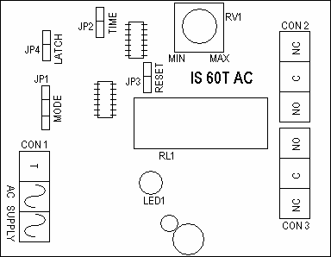

Trigger inputs:
The timer will start when an input is applied to the ‘T’ terminal. The input can be a brief pulse or a continuous signal.

Supply Voltage | 12V AC | 24V AC
Quiescent Current | 4 mA | 14 mA
Current when active | 50 mA | 70 mA
Double Pole Relay rated at | 8 Amps at 240 V AC  minimum 10 mA
Dimensions | 57mm (W) 85mm (L)  20mm (H)
Packing weight | 50g

We recommend IS Sticky Feet Size B,
self-adhesive mounting pillars to ensure
a neat fixing.

